**Lubango Festival**

There are-several Angolan festivals, holidays, and celebrations. These revolve mostly around religion, art, and music.

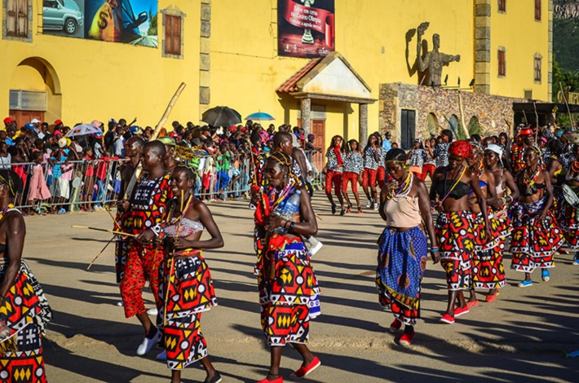

Based on the feast of Our Lady of the Hill, Lubango Festival is a 30-day celebration held in Lubango City in Angola’s Huila Province. Beginning in August, it features music performances, fashion parades, a sports tournament, motorbike racing, and the prestigious Miss Huila beauty pageant. The festival also kicks off the Expo-Huila trade show, along with some workshops and a cattle auction.